Exercise 2. Producing a species distribution map

In this exercise, you will create two different representations of a species distribution according to the IUCN mapping standards.

|  |  |
| --- | --- |
| Skills Acquired | Data needed |
| How to select features in a vector layer  How to clip between vector and raster layers  How to create a fixed distance buffer around a data point  How to extract new information from different GIS layers  How to stylize a raster layer | - Global National Boundary (land borders, EEZs etc) vector File  - Clean Global Occurrence Vector File  - Environmental Variable Data Layer (Raster or Vector) containing values indicative of species habitat preference |

# Create a 10km buffer around data occurrence points

* *Ensure that mmQGIS is installed as a Plugin*

*QGIS offers a range of plugins that be added and that increase functionality. For this exercise we will use mmQGIS, a set of Python plugins for manipulating vector layers.*

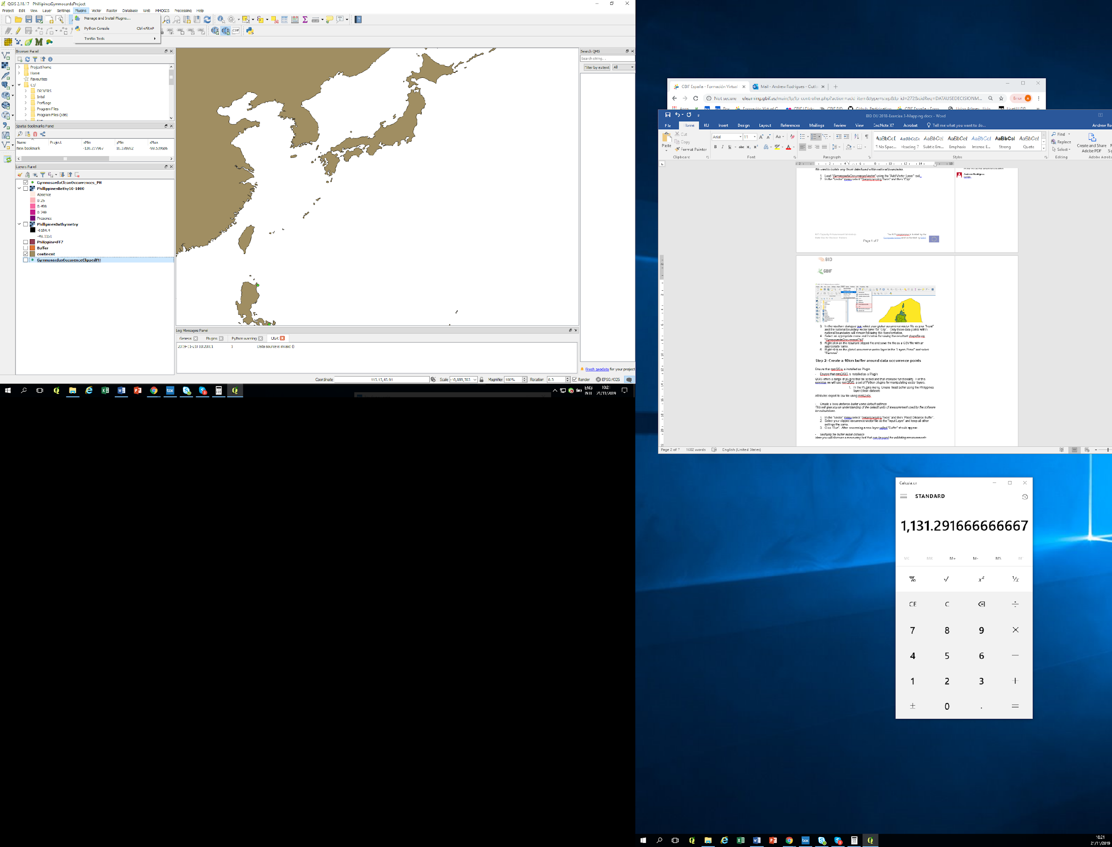

1. In the Plugins menu, select “Manage and Install Plugins”
2. Search for mmQIS, select it and click on “Install Plugin”. Close the pop up window. This will install mmQGIS and you should now have an mmQGIS drop down menu in your menu bar.

* *Load a national boundary vector layer*

*We want to create a polygon that contains all areas under national jurisdiction. This could be land or marine territory or both depending on the species of interest and you would use a dataset containing global national boundaries to calculate this, if you did not have one already.*

* Load the Philippines boundary vector and worldEEZ file using the “Add Vector Layer” tool, as you did in the GIS-based data cleaning exercise.
* Select the EEZ of interest using the “Select Feature(s)” icon.
* Right click on the global national boundary vector layer in the “Layers Panel” and select “Save as..”.
* In resultant dialogue box, check the box “Save only selected features” and save the layer as a shapefile with an appropriate name e.g. “PhillippinesEEZ”.
* Right click on the global national boundary layer in the “Layers Panel” and select “Remove”.
* *Create a fixed distance buffer around your occurrence data*

*We want to create a buffer of radius 10km around our data points. We can do this using the fixed distance buffer tool in the Vector drop down menu, however, the process is simplified in mmQGIS, where you can set buffer distances in kilometres.*

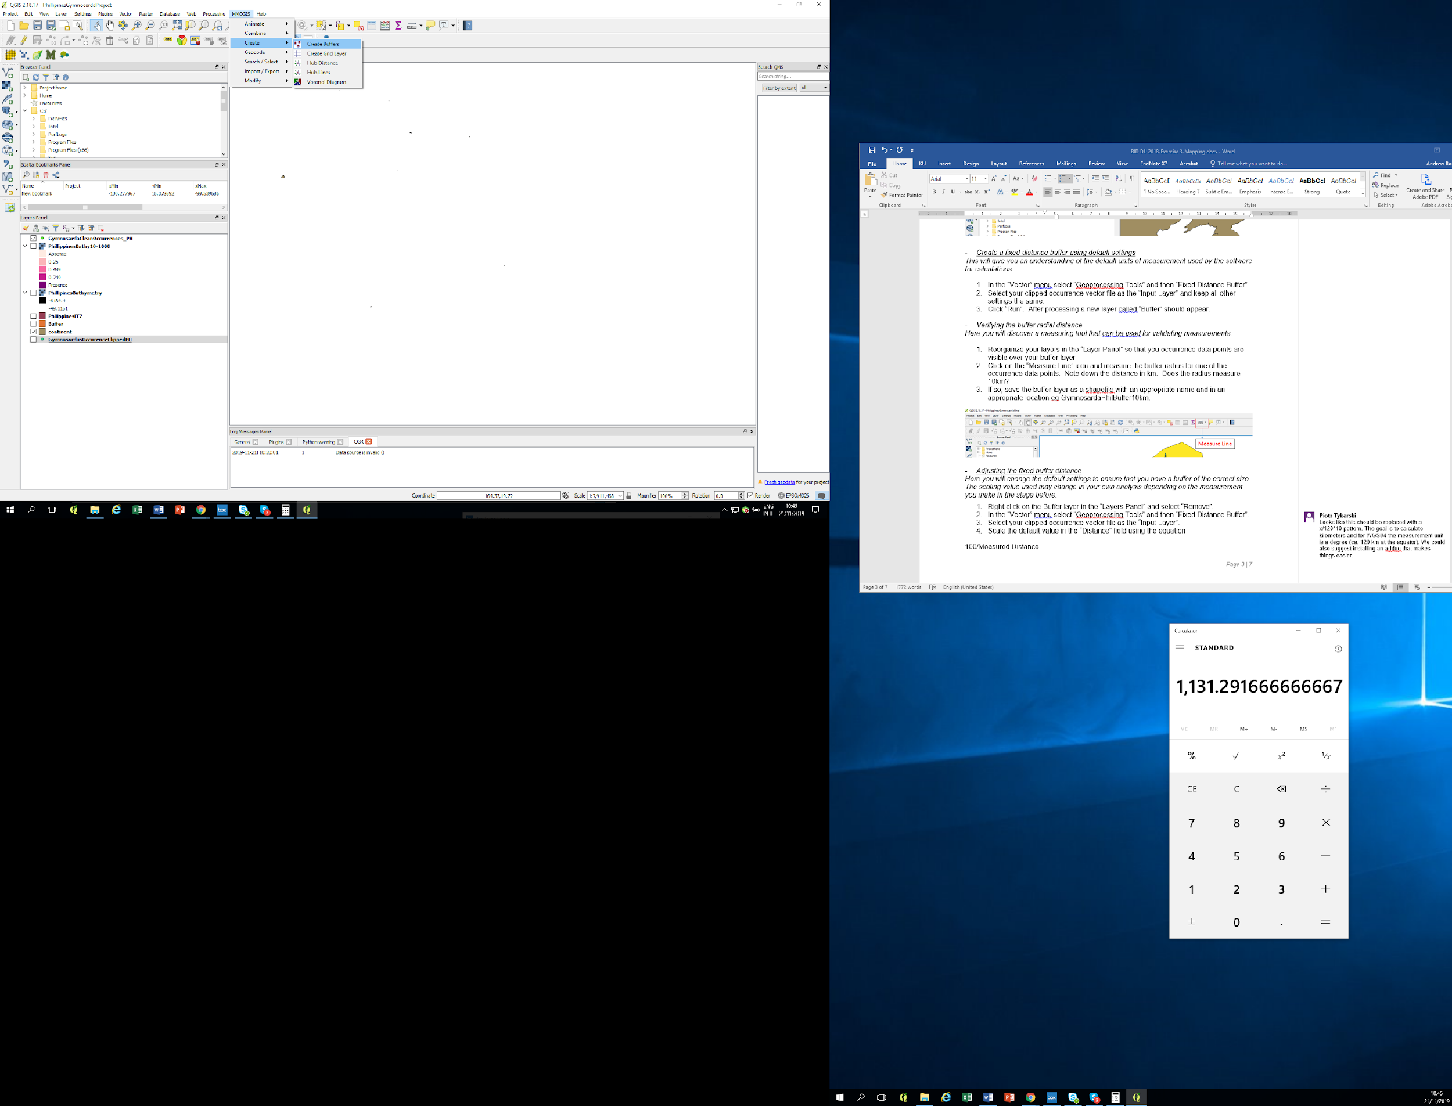

1. Load the Philippines *Gymnosarda unicolor* dataset
2. Select “Create buffers” in the mmQGIS drop down menu
3. Select the dataset for *Gymnosarda unicolor* as your Source Layer and set the fixed radius as 10 with a Radius Unit of kilometres. Select the Fixed Number of Edges as 64 for a smooth circle buffer. You can leave the other fields with default values.
4. Name your output shapefile and choose a location to save your resultant shapefile.
5. Press OK. This should create a 10km buffer around your data points.
6. You can reorganise your layers to crop your buffers using the Philippines layer.

* *Verifying the buffer radial distance*

*You can validate the buffer distance using a measuring tool.*

# Reorganize your layers in the “Layer Panel” so that you occurrence data points are visible over your buffer layer

1. Click on the “Measure Line” icon and measure the buffer radius for one of the occurrence data points. Does the radius measure 10km?

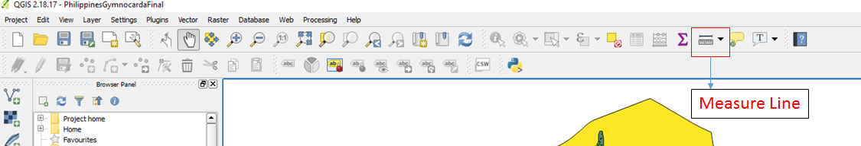

* *Export the required and recommended attributes required for a red list map*

*We will now create a csv file containing all the necessary fields for a red list map.*

1. Select “Import/Export” in the mmQGIS menu and then “Attributes export to csv”
2. Select the Philippines occurrence data as the Source Layer and select those attributes required and recommended for a red list map
3. Name your resultant csv file and choose a location to save your resultant file
4. Press OK. You now have all the necessary elements for submission of red list map using a buffer protocol.

# Create a distribution map based on suitable habitat (Optional)

* *Add an environmental variable raster data layer*

*In this stage we will add our first layer of environmental data.*

1. Click on the “Add Raster” tool to the extreme left of the QGIS window.
2. Load the bathymetry layer “10m_bathy.asc” and hit “OK”.
3. In the “Coordinate Reference Selector” window, leave everything at default values and click “Ok”.

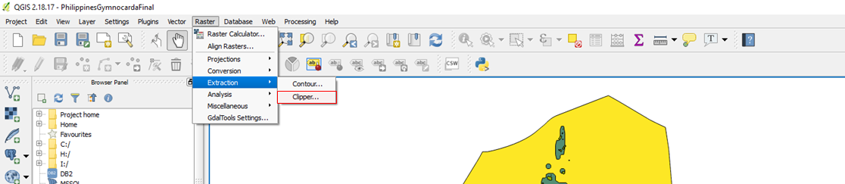

* *Clip environmental variable raster data layer to a national boundary vector layer*

*We want to ensure that we only have national-level environmental data*

1. In the “Raster” menu select “Extraction” and then “Clipper..”.
2. In the resultant dialogue box, select your environmental variable raster datalayer as your “Input”.
3. Select an appropriate name and location for saving the resultant file as a GeoTIFF or shapefile in the “Output file” field eg. “PhilippinesBathymetry”.
4. In the clipping mode box, check “Mask Layer” and select the national boundary vector layer as the “Mask layer”. Press “OK”. A new layer will be created in your “Layers Panel” only containing environmental variable values within national boundaries. (Should you get a warning stating – “Output driver `GMT' not recognised or does not support direct output file creation…”. Try modifying the gdalwarp script at the bottom of the dialog from "-of GMT" to "-of GTIFF"  by clicking on the pencil, making the modifications in the text and pressing “OK”.)
5. Right click on the global environmental variable raster datalayer in the “Layers Panel” and select “Remove”.

* *Identifying areas of suitable habitat*

*We want to identify those environmental parameters at a national level that may allow us to identify areas of suitable habitat for our species*

1. Re-organize your layers in the “Layer Panel”so that your occurrence data points are visible over the other layers.
2. In the “Layers Panel” select the clipped environmental raster layer.
3. Using the “Identify Features” icon, click on an occurrence data point. What is the value at that point for the clipped environmental raster layer?
4. Select a range of environmental variable values that best describe the habitat requirement of those species by using the “Identify Features” function. For this example we will use a range of depths from 10 to 1000m. (Please note, where additional information is available on the habitat of a species from scientific publication or expert knowledge, this information should be incorporated.)

* *Creating a raster layer of areas of suitable habitat*

*We want to select only those areas within our environmental dataset that are contained within the set of environmental parameters that we identified in the previous stage.*

1. In the “Layers Panel” select the clipped environmental raster layer
2. In the “Raster” menu select “Raster Calculator…”.
3. Select an appropriate name and location for saving the resultant file as a GeoTIFF in the “Output layer” field eg. “PhilippinesBathy10-1000”.
4. In the Raster calculator expression box, input (note that you can select the file name below from the list):

((-10) > “PhilippinesBathymetry@1”) AND ((-1000) < “PhilippinesBathymetry@1”)

Click “OK”. This will select all areas in the clipped environmental data layer where values are between -10 and -1000m below sea level.

1. Right click on the clipped national environmental variable raster layer in the “Layers Panel” and select “Remove”.

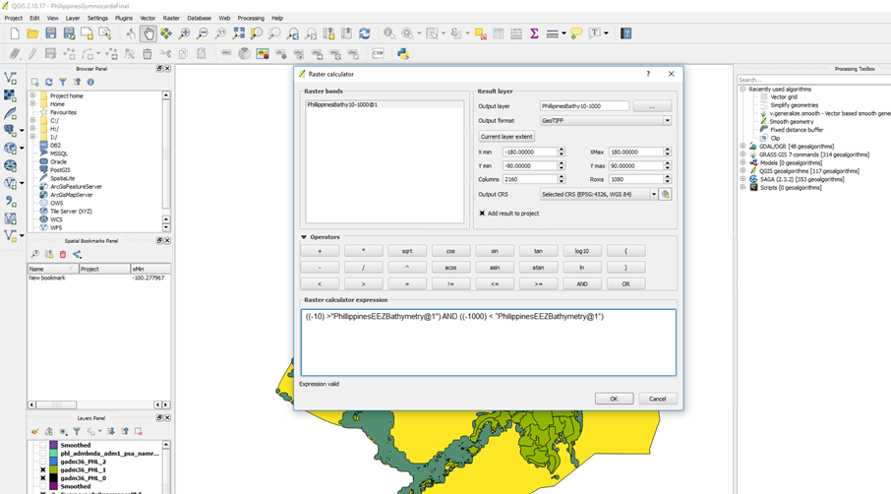

* *Stylizing a raster layer*

*Stylizing our maps allow for easier comprehension of our analyses.*

1. To highlight those areas of suitable habitat, Right click on the suitable habitat raster layer in the “Layers Panel” and select “Properties”.
2. In the resultant dialogue box, click on “Style” in the left column
3. At the top of the box you will see “Singleband gray” selected. Click on this drop down menu and select “Singleband Pseudocolor”.
4. Select your preferred color palette from the drop-down menu in “Color”.
5. Scroll down in the box and click on “Classify”. A set of colors should appear in the box with associated values.
6. In the legend column, replace “0” with “Absence” and “0.999” with “Presence”.
7. Click on “Apply ”and then “OK”. The ENM rasterlayer will be recolored to clearly show absence and presence of the species. You should now have a map of suitable habitat for your species.
8. Remember to save your project.

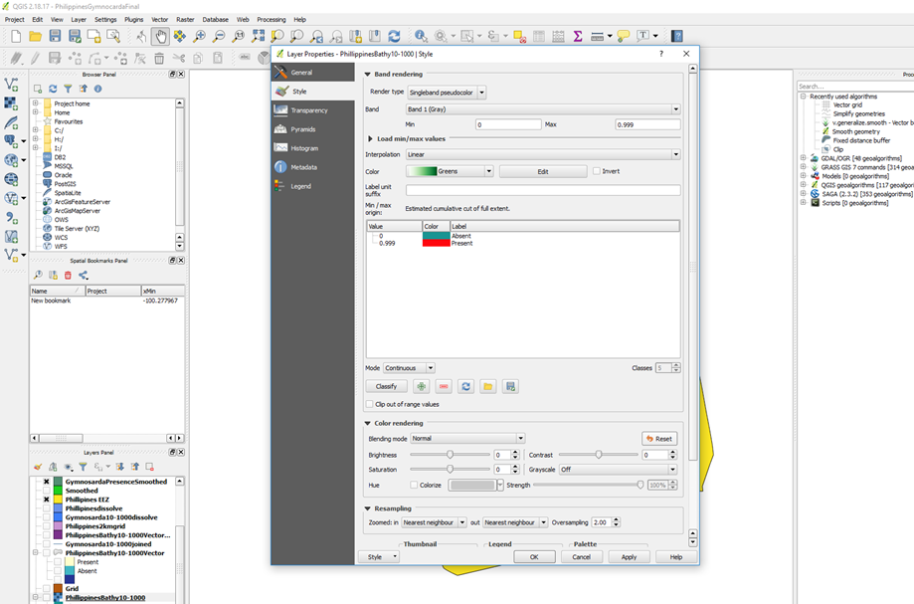

# Step 4 (Bonus): Smoothing your map

# *This is an additional style requirement for publishing on the red list and will smooth the lines of your polygons*

* *Convert an ENM raster data layer into a vector layer*

1. In the “Raster” menu select “Conversion” and then “Polygonize (Raster to Vector…)”.
2. In the resultant dialogue box select your suitable habitat raster layer as your “Input”.
3. Select an appropriate name and location for saving the resultant shapefile in “Output file for polygons (shapefile)” eg. “PhilippinesBathy10-1000Vector”.
4. Click “OK”.
5. Right click on the ENM raster layer in the “Layers Panel” and select “Remove”.

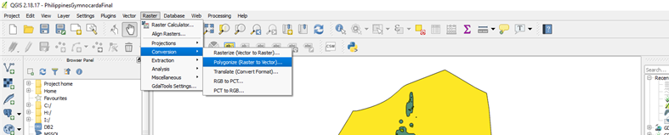

* *Smooth a suitable habitat vector data layer*

1. In the “Processing” menu select “Toolbox”. A side menu should appear.
2. In “QGIS Geoalgorithms” select “Vector Geometry Tools” and then “Smooth Geometry”.
3. In the resulting dialogue box, select the suitable habitat vector layer and adjust the values for iterations (the higher the number the smoother the curve) and outputs (the smaller the number the lower the degree of offset of the smoothed polygon form the original polygon).
4. Press “Run” and save the resultant layer. You have now created a smoothed suitable habitat polygon for your species.

